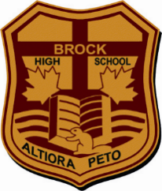
Brock High School
School Community Council Meeting
Tuesday, September 20th at 7:00 pm

Start Time at 7:00 pm
W. Jovel, Pam Koster, Kristin Bagshaw, Erika Loutskou, Tracy Shier, Ellie Davidson

Acknowledgement of Traditional Lands, Indigenous Inherent Rights, and Human Rights Statement.

Welcome- Chair Kristin Bagshaw

- Review of Google Meet Procedures and Norms of Meeting
- participation and reflection

- Review of Agenda; Review of Minutes of last meeting

- Treasurer’s Report –$500

- Staff Update – Mr. Jovel & Ms. Koster
-Hub meeting with community partners, they would like to see more student voice on what they (the students) would like to see at the Hub. Form going to Home Rooms for students to fill out. This should be handed out Thursday. Late buses will be running Tues. and Thurs. at 5 p.m.
-Extra Curriculars are running. Rugby being scheduled so students can use the late buses.
-Commencement will happen on Friday before Thanksgiving. Office staff working to package up diplomas and awards.
-Cafeteria is up and running. Start was delayed due to a staffing issue but that has been corrected.
-Mrs. Koster is working on the mark-reporting dates. Oct. 6 Progress Reports will be coming out.
Parent/Teacher interviews to be finalized week after Progress Reports.
-EQAO is moving forward. OSSLT Nov.2 – Dec. 7(window test is available) & Mar-Apr for second round. Results for fall test available Jan.
-Student Council representatives, not a strong interest so far but announcements have been going out. 1st meeting will be held Wed. Sept. 21 at lunch. This year there is low return of students due to Gr. 12’s graduating.
-Staff Rep, Mr. Weber will stay on as rep.
-End of year assembly will be brought up at next staff meeting in October.

- Current Topics
-Kristen asked if gym space open at lunch. Gym is busy with pick up basketball. Leadership club starting inter-murals. The gym is not a place to eat lunch now that the cafeteria is open.
-Kristin asked if there could be volunteer drivers for students to sporting events with the shortage of busing. Reply was yes there could be volunteer drivers.
-Kristen asked if there will be any info sessions for this year’s grade 12’s for colleges, universities, applications etc. Post-secondary institutions have been invited in to speak to students, classroom visits will also happen by guidance. Laurentian has already been to the school to speak.
-Kristen wanted to know about Fundraising but will table it to the next meeting.
-Kristen asked if recognition in the hallways will be updated and if there are still yearbooks available. There are some yearbooks available.
-It was asked if school clothing would be available this year. Ms. Brooks & Ms. Johnston are co-chairing. Marketing class will be working with them as well.
-Uniforms, will there be more options, coaches will be asked what type of uniforms they are interested in.
-Question was asked about Skills. Are students receiving help from skills? Skills is now a quiet place to work-promoting independence. Some parents are getting mixed messages on what skills can provide for their children. If students are going there, they are looking for an alternate form of explanation to a subject but being directed toward an independent approach.

- Open Discussion
-Are we keeping the same roles for SCC. C. Marquis is stepping down. Kristen will now chair. All other positions to remain the same.
-Update next meeting on Student Council
-Next meeting Nov 8, 2022

Motion to adjourn by Tracy, seconded by EL 8:05 p.m.

Important Dates SCC Dates (6 meetings)
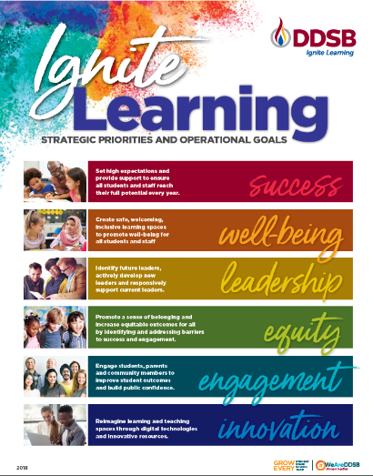 | Sept. 20
 | Nov. 8
 | Follow us on Twitter
 | @BrockHighSchool

